Starter App

Description

StarterApp is a base setup for any application which requires User Management ,Import and Export ,Email Module ,REST API Integration and Mendix SSO Enabled(IDP configured with Mendix Developer Portal ) components. This module consists of already existing components which are essential for most of the application.

Features:

* App end-user access management that is handled in the Mendix developer portal.
* Simple steps for adding module in you app doing few configurations.
* Starter App is the Base Setup for multiple application which requires some comman modules like Import-Export,Email,Single Sign on,API Integration.

Limitations:

* Setup Configurations separately.

Modules Integrated in Starter App

1.User Excel Management

This module covers CRUD operation on User Entity with default password settings, Importing the data from external excel sheet, Exporting/Downloading the user data to excel sheet. Also creating login functionality and rights as per assigned roles (user/admin) .

Refer [User Excel Managemen](https://marketplace.mendix.com/link/component/212366)t Documentation

2.Email Module

Sending and receiving email is a crucial part of any Application. But you might be thinking how we can achieve this in step by step manner. This module will cover how to Effectively run and set your own template of email module by using Mendix in your application? Let’s start!

**Prerequisites:**

Download following :

• Mendix 9.24.0 version.

• “email module with templates”

• Mx Module Reflection

• Encryption

• CK editor for mendix

**Mx Module Reflection**:

This module is Used for templates features in Email Template which is used to create tokens to include in your template. Also it will modify the data from your database before sending email.

**Encryption**:

This module is used to encrypt your SMTP password. The password gets decrypt prior to sending email.

**CK editor for Mendix:**

CK editor is a widget with an extra button that allows you to create microflow even in your HTML output.CK editor comes with CK editor viewer which preview the look for the template you set. You can design buttons and links or just a text using this widget.

**Note**:

As we know that the widget and module are already present in the marketplace but for Email module there is no proper Step by Step implementation provided. This Documentation will provide implementation with the proper explanation of Email Module in Mendix.

**Steps To Configure Email Module in starter application?**

* Install the pre requisites for email module
* Use the Email Administration snippet in your module to display data.
* make the snippet of buttons "Send link" and "Send Attachment" and use it in your module.
* Add Email Administration page to navigation.
* Add MX Reflection in Navigation
* Run your app.
* In Mx Module Reflection check the Email Custom and Email template and then "click to Refresh" button.
* Default template is already set.
* Make your own server configuration in Server Configuration Tab.
* Make sure you change the email in microflow accordingly for Send link and Send Attachment microflow for create activity.
* For further setup of template do follow Setup Template section thoroughly.

**Implementation of Email Module In mendix:**

1. Create a App Named “EmailTemplateModule” and then rename a Module Name from MyFirstModule to “EmailCustom”
2. Create a Page EmailAdministration and Select snippet widget and add the Administration Snippet. (from EmailTemplate.Administration) image

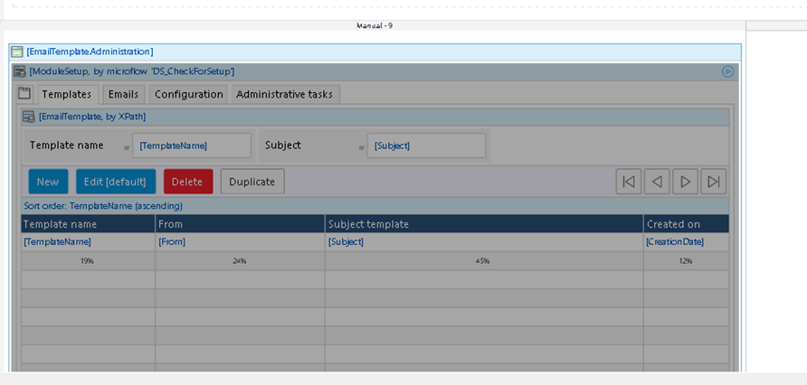

1. Add EmailAdministration Page to your Navigation Tab.

1. Create a Entity in your Domain Module named “EmailInfo” and add a attribute “EmailAddress” of type String.This attribute will be used to create Email template.

1. Create a microflow “CreateAndSendEmail” to send an Email. No Worry to build from scratch you can duplicate the Microflow from EmailTemplate Module and replace a order parameter with EmailInfo Parameter also Customer parameter with EmailAddress parameter as shown below:

1. Once you do that you will get an error in the change activity in this microflow. Open the change activity and change the “To” attribute value to your email address parameter.
2. Finally create a Microflow named “RetrieveTemplateAndSendEmail” as shown below:

1. This microflow is used to retrieve the Email template checks for empty template and atlast calls “CreateAndSendEmail” microflow. 8. Now this is not Done yet! Run your Project and setup the MxModuleReflection and Encryption.As displayed below

1. Set the MxModuleReflection Overview Page to Navigation.

1. After that expand the encryption module and set a value for the constant called “EncryptionKey;” this value needs to be a 32-character string.

Now you can run your project. Open the MxModuleReflection and Synchronize Entity and Attributes by Clicking “ClicktoRefresh” button.

1. Next, navigate to the email administration page and perform the first-time setup. I like to use a Gmail address to send emails with, but you can use any smtp settings. • Gmail SMTP server address: smtp.gmail.com • Gmail SMTP username: Your full Gmail address (e.g. emailtestingnagarro@gmail.com) • Gmail SMTP password: Your Gmail password(to set this password you need to Turn on your Less Secure App from google settings Or alternative for this method is under 2 factor authentication Go in App Password where you will see a generated password copy and paste it here) • Gmail SMTP port (TLS): 587 • Gmail SMTP port (SSL): 465

Once you have entered your credentials, you can click the “next” button and proceed with sending a test email.

Make Sure you turn on the “Allow Less Secure Apps” setting. If you run into this issue, the error that will be returned will be that your password is incorrect.

Now, setup a template with a token, and then send an email from a microflow.

**Setting up the Template For Email Module**

1. The first thing you should do is open the “My First Template” example.

1. Then scroll to the bottom and find the ‘tokens” section. Here is where you can link an entity and its attributes from your database to your email templates.

1. We have used the “EmailInfo” table in the EmailCustom module.
2. Select object “emailinfo” and then press “new” to create a token for each attribute in your selected object. We have only one attribute “EmailAddress”.

1. The “token” field would be the name of your token, the “type” would be attribute, and the “attribute” field is where you would select “info.”
2. Add token to your body now! token would be “{%TestToken%}"in your HTML.

1. Create a microflow named “SendEmail” as shown below:

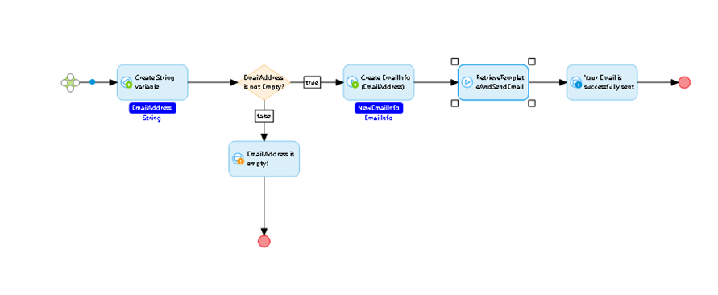

1. Call this microflow on the button onClick Function. This microflow is used to Send Email Successfully.
2. Next run your application and then press the button that you just added. There will be a popup message if your email was successful, and you should receive an email in your inbox.

Congrats! You can now Send Email According to your Designed templates.

This was all about the Sending Email From Mendix.

3.Import and Export

**Pre-Requisites-**

* Mendix Version 9.24.0
* Mx Module Reflection
* Excel importer module
* Excel Exporter module

**Steps To Configure Import-Export in starter application?**

* Install the pre requisites for Import and Export.
* Download MX reflection
* In Mx Module Reflection check the Import and Export table and then "click to Refresh" button.

**For Import-**

* In the Excel Import Overview Page, Click **New** **template from Excel file** and select your data excel file as the Excel file. Click **Save & next**.
* Change the Mendix object according to your importing data.
* Modify the column according to your needs in the Connect Column with attributes section.
* In the Excel Importer Overview page, click on import file.
* For further setup of template do follow implementation section thoroughly.

**For Export**-

* Add your data and click on export default button, it will automatically export data in excel file.
* The second method will be-
* Just modify the column data according to your need.
* Save 2x.
* Modify the entity in **SUB_CreateExcelExport** for retrieval.
* Run and export.
* For further setup of template do follow implementation section thoroughly.

**Importing Data With Excel**

* Download the "Mx Model Reflection" and "Excel Importer" modules from the Mendix Marketplace and install them in your environment.
* Create menu items for the "Excel Import Overview" and "MxObjects Overview" pages. Place them under an "Admin" navigation menu.
* To synchronize the entities and microflows of the "App" module, follow these steps: a. Run and view your application. b. Navigate to the "MxModelReflection" page using the menu you created in step 2.

Please refer to the following link for more steps.

[Mendix Academy - 4.1.2 Import Stores and Countries](https://academy.mendix.com/link/modules/142/lectures/1224/4.1.2-Import-Stores-and-Countries)

**Export Data with Excel**

* Download the "Excel Exporter" module from the Mendix Marketplace and install it in your Mendix development environment.
* Add a menu item for easy access to the "Excel Document Overview" page.
* Add a new entity to your domain model and name it "ProductExcelDocument." This entity should be a specialization of "System.FileDocument."
* Create a many-to-one association from the "Product" entity to the "ProductExcelDocument" entity.

* Run the application and Re-synchronize **App**module’s entities and microflows using **MxModelReflection.**

**Create a new Excel Export template- (Second Method)**

* Open the running application and navigate to the "Excel Export Overview" page.
* Click on the "New" button on the page.
* Set the file name as "PolicyExport".
* Select "PolicyExcelDocument" as the input object.
* Choose "Excel 2007 and higher" as the document type.
* Select "dd-mm-yyyy" as the date time export format.
* Click the "New" button under the "Worksheets" section.
* Set the name as "Policy".
* Select "Policy" as the row object.
* Choose "Default" for both the default text style and default header text style.
* Click the "New" button (under the "Column data" tab) for each of the Product properties - "Number", "Name", "Unit Price", "Color" - and one for the "Name" (reference).
* Click "Save" twice to save the configuration.
* For more information, and creating microflows, refer to the following link-

[Mendix Academy - 7.3.2 Entities, Microflows and Excel Template Configuration](https://academy.mendix.com/link/modules/136/lectures/1267/7.3.2-Entities,-Microflows-and-Excel-Template-Configuration)

4.REST API Integration

This module covers how to retrieve data from API in Mendix.

Pre-requisites

Download following :

• Mendix 9.24.0 version

**Steps To Configure API Integration in starter application?**

* Install the pre requisites for API integration module.
* In “JSON_Users_Structure” User have to copy his JSON that is displayed and then paste it in the JSON structure content.
* Now Click on refresh
* In the domain model click on “Map automatically”.
* Run the app
* For further setup of template do follow implementation section thoroughly.

**Retrieve data from API in Mendix.**

API for testing and prototyping, to make a REST call to retrieve data of users in a JSON format and display it in the application.

1. First in your module “Add a microflow”  that will have the logic to make the  REST call to retrieve the data is created.
2. Create a JSON structure that will indicate how we are going to be receiving the data from the API.
3. Now, in [JSON Placeholder page](https://jsonplaceholder.typicode.com/), look for /users in resources and open it in a new tab in your browser. Copy the JSON that is displayed and then paste it in the JSON structure content.
4. Add a new activity in the microflow and the type of action will be “Call REST service”and then edit the set the location and put https://jsonplaceholder.typicode.com/users. In the Response tab,select “Store in a string” for Response handling and then provide the variable.
5. Now, Create an import mapping so when we get a response back, we will map this data to an entity to store this users inside our application and then select the JSON structure that we have created.
6. The Final will look like this.

1. Go to “Home_Web” page, add a Data Grid widget in the Layout grid.
2. Click on the Data Grid and go to Data Source and select microflow, then select the microflow that we created.

1. Select Yes for automatically fill data and for the server side paging.
2. Save files and run locally.
3. The final page will look like this.

1. Mendix SSO Enabled

This module covers about the mendixSSO configuration.

**What is in mendix starter app SSO**

Mendix SSO configuration to enable SSO in application is already done in starter app where identity provider (IDP) is mendix developer portal if there is need to customize IDP we can modify using this mendixSSO official [documentation](https://docs.mendix.com/appstore/modules/mendix-sso/#customizing).